Selection Sort

//Selection Sort

#include<stdio.h>

#include<conio.h>

int count=0;

void selection(int a[], int n)

{

int i=0,pos,temp;

// int l=0;

for(i=0;i<n;i++)

{

pos=smallest(a,i,n);

temp=a[i];

a[i]=a[pos];

a[pos]=temp;

}

}

int smallest(int a[],int k,int n)

{

int pos=k,j;

int small=a[k];

for(j=k+1;j<n;j++)

{

if(a[j]<small)

{

small=a[j];

pos=j;

}

}

return pos;

}

void main()

{

int a[10],n;

int i,j;

clrscr();

printf("How many numbers you want to enter ?\n");

scanf("%d",&n);

printf("Enter %d numbers:\n",n);

for(i=0;i<n;i++)

{

scanf("%d",&a[i]);

}

selection(a,n);

printf("The sorted elements are :\n");

for(i=0;i<n;i++)

{

printf("%d ",a[i]);

}

getch();

}

OUTPUT:

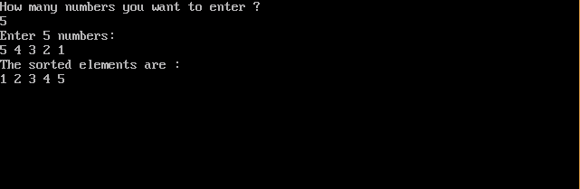

Insertion Sort

//Insertion Sort

#include<stdio.h>

#include<conio.h>

int a[10],n;

void insertion(int a[],int n)

{

int i,temp,j,temp1;

for(i=1;i<n;i++)

{

temp=a[i];

j=i-1;

while(temp<a[j] && j>=0)

{

a[j+1]=a[j];

j=j-1;

}

a[j+1]=temp;

}

}

void main()

{

int i;

clrscr();

printf("How many numbers you want to enter?\n");

scanf("%d",&n);

printf("Enter %d numbers :\n",n);

for(i=0;i<n;i++)

{

scanf("%d",&a[i]);

}

insertion(a,n);

printf("\nThe sorted elements are:");

for(i=0;i<n;i++)

{

printf("%d ",a[i]);

}

getch();

}

OUTPUT:

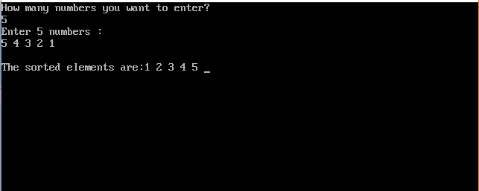

Bubble Sort

//Bubble Sort

#include<stdio.h>

#include<conio.h>

void bubblesort(int a[],int n)

{

int i=0,j;

int temp;

for(;i<n;i++)

{

for(j=0;j<n-i-1;j++)

{

if(a[j]>a[j+1])

{

temp=a[j+1];

a[j+1]=a[j];

a[j]=temp;

}

}

}

}

void main()

{

int a[10],n,i;

clrscr();

printf("How many numbers you want to enter?\n");

scanf("%d",&n);

printf("Enter %d numbers :",n);

for(i=0;i<n;i++)

{

scanf("%d",&a[i]);

}

bubblesort(a,n);

printf("\nThe sorted elements are :\n");

for(i=0;i<n;i++)

{

printf("%d ",a[i]);

}

getch();

}

OUTPUT:

